Independence Table
John Wensink
ITS410 - Database Management
Colorado State University-Global Campus
Dr. Dan Morrill
November 24, 2019

Independence Table
This week’s assignment was to create a new table in the world-x database. It was not necessary to use the root user to complete this week’s assignment, as last week we granted privileges for the user ‘jump’ to include select, insert, update, and drop. The user ‘jump’ was chosen as it satisfies one of the primary considerations of information security, to use the Principle of Least Privilege when operating a database (Saltzer & Schroeder, 1975). Creating the table ‘independence’, the attribute ‘id’ was selected to be the primary key, as the auto_increment function would prevent any two rows from having the same value. The United Nations recognizes 195 independent countries, and as such, it made sense to use the tinyint data type which has a signed range of -128 to 127 characters, and an unsigned range of 0-255(MySQL, 2019 Section, 11.1.2). The unsigned data type is perfect as we will not be using negative numbers for our ‘id’ primary key, the storage size is just one byte, and there is plenty of room left in the range for newly independent nations. The auto_increment function allows us to omit the “id” attribute when inserting data, as it will automatically increase the value by one higher than the previous entry. Although an increment of one is selected as default, the command
“SET @@SESSION.auto_increment_increment=2;” (Tocker, 2011) could be used to change the increment to two, just for the current session. If we wanted a more persistent change, the command “SET @@GLOBAL.auto_increment_increment=1;” (Tocker, 2011) could be used to make this change for all future sessions. Below, the command used to create this table is shown, as well as a screenshot of the table ‘independence:

1.) USE world_x;
2.) CREATE TABLE independence (
id TINYINT UNSIGNED NOT NULL AUTO_INCREMENT,
country_name VARCHAR(50),
independence_date DATE, PRIMARY KEY (id)
);
3.) INSERT INTO independence(
country_name, independence_date)
VALUE ('United States','1776-07-04');
4.) SELECT * FROM independence;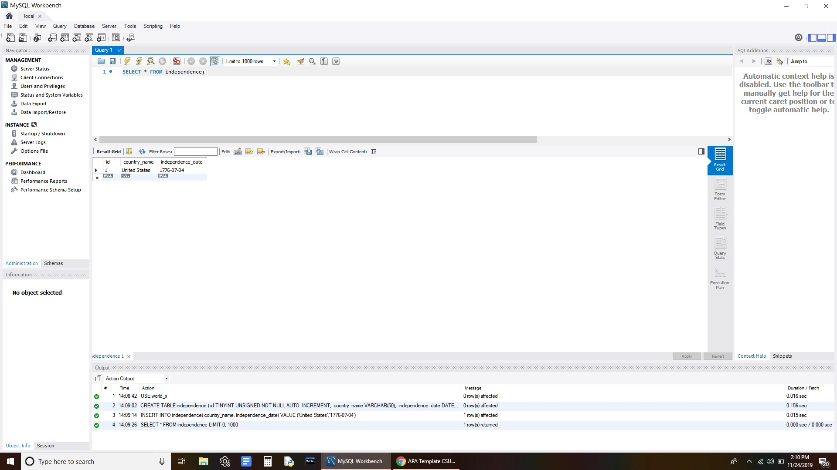

References
MySQL. (2019, November 23). MySQL 8.0 Reference Manual: 11.2.1 Integer Types (Exact Value) - INTEGER, INT, SMALLINT, TINYINT, MEDIUMINT, BIGINT. Retrieved November 24, 2019, from https://dev.mysql.com/doc/refman/8.0/en/integer-types.html.
Saltzer, J., & Schroeder, M. (1975). The Protection of Information in Computer Systems. Proceedings of the IEEE, 63(9), 1278–1308. Retrieved from http://web.mit.edu/Saltzer/www/publications/protection/
Tocker, M. (2011, September 11). MySQL Auto_increment going 2 by 2. Retrieved November 24, 2019, from https://dba.stackexchange.com/questions/5656/mysql-auto-increment-going-2-by-2.

